for RESEARCH IN ELA AND TECHNOLOGY
Edited by Sara Kajder and Carl Young

Virtual Worlds for Literary Study:
Technological Pedgogical Content Knowledge in The Village of Umuofia
and other Literary Worlds

Allen Webb

The Literary Worlds Project at Western Michigan University involves a team of literature teachers creating and researching diverse, immersive, and interactive virtual reality environments to support the teaching of a wide range of literary works from Anglo-Saxon poetry and Shakespeare plays, to 18th Century novels, commonly taught modern works and young adult fiction. Using these technology-rich pedagogical tools directly related to specific works taught in secondary or university English classes students role play as literary characters extending and altering character conduct in purposeful ways, explore on-line, interactive literature maps, museums, archives, and game worlds to analyze the impact of historical and cultural setting, language, and dialogue on literary characters and events. Between 2005 and 2009 seventeen different literary worlds have been created and implemented by literature teachers and scholars – none of them technology specialists. Free, non-profit educational resources, these worlds have been extensively visited by students around the world. This pioneering project provides a laboratory for research into the utilization of virtual spaces in the teaching of literature.
Literary Worlds engages English language arts content scholarship, self-conscious pedagogical experimentation and research, and the application and development of remote participation, object-oriented multi-user domain, Internet technology. The mutual development of these different content, pedagogical, and technology knowledges (TPACK), requires a dynamic and continuing evolution and exchange (Koehler & Mishra, 2009). We have found virtual literary worlds to facilitate constructivist learning in diverse ways depending on their incorporation of active reading, specific textual language, narrative structures, textual geographies, examination of historical and cultural contexts, visual and aural representations, student interaction and discussion, and student analytical, creative and perspectival writing. After describing the development of technology, pedagogy, and content in these virtual worlds this chapter will closely examine an exemplary virtual literary world, The Village of Umuofia, and conclude by setting forward a typology of virtual world instructional forms developed in the Literary Worlds project.

Technology
The technology framework for the Literary Worlds Project is enCore 4, an open-source software package emerging from text-based multi-user domain technology and designed for educational use. Built on LambdaMOO (a Multi-user domain Object Oriented) with a built-in server-side client called Xpress, enCore allows builders to create on-line learning environments, featuring visual images, easy navigation between rooms, static avatars, synchronous participant communication, textual activities, the incorporation and complex utilization of a wide range of objects including textual, visual, audio and video files, maintenance of running records of actions and speech, the incorporation of “bots” (virtual characters with a pre-programmed speaking repertoire), and a wide range of programmable options. EnCore is not three dimensional, but it is an immersive, self-contained multi-user virtual environment (MUVE). (For a history of these environments see Rozema 2004, chapter 3.)
The prototype virtual literary world was created by Robert Rozema and his students for studying Aldous Huxley’s Brave New World. At the time a high school English teacher working part-time on a doctoral degree under my direction, Rozema completed a doctoral dissertation in 2004 addressing, in part, his significant innovation. Rozema’s 2003 NCTE presentation about his experience teaching secondary students using the virtual world he developed was given the National Technology Leadership Award, and he authored an article in the English Journal (Rozema, 2003). Additional worlds created by Rozema (Thoughtcrime), Joe Haughey (Midsummer Madness), Cara Arver (Lord of the Flies), and myself (Village of Umuofia) became the models for the grant that funded the Literary Worlds Project.
Maintained on a dedicated server at Western Michigan University, the Literary Worlds team has used enCore-based architecture to develop targeted resources, protocols, and programming for the specific creation of literature-related virtual worlds. In this way specialized content and pedagogical knowledge has been used to enhance the technology platform, consistent with TPACK theory. The enCore Literary Worlds user interface (fig. 1) (taken from the Village of Umuofia) illustrates: 1) a touch button control bar; 2) a running record of places visited, actions taken, and conversation transcript; 3) a dialogue box where participants can input commands, speech and actions; and, 4) the room name, image, clickable objects (“Music,” “Disguised Man”), character avatars, and links to connected rooms.
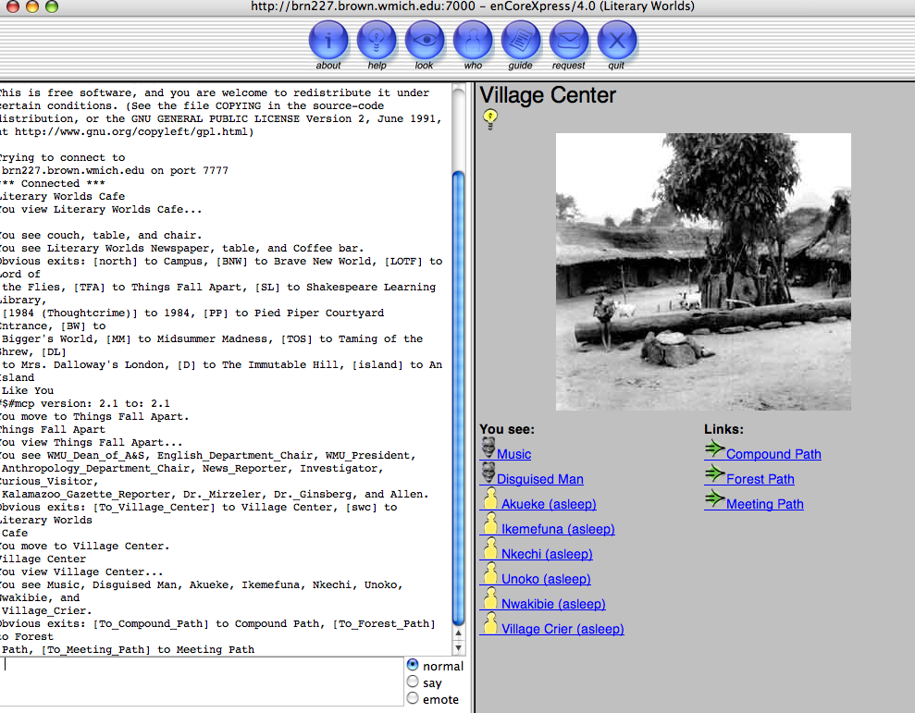
Figure 1
Sound and video files can be cued to play when characters enter the “room.” Technology interfaces are crucial to their function (Johnson, 1997), and as this chapter will illustrate with the Village of Umuofia, we have been able to invent a range of ways this interface can be utilized for the development of virtual literary worlds. While the enCore interface does not offer the same sensory experience as contemporary video games or more sophisticated virtual worlds, such as Second Life, its simplicity does have advantages. The enCore platform does not require any special software be downloaded onto computers accessing it and can work well on a wide range of machines, including those with slower processors. All that is needed is web access and a standard browser set to “accept popups.” Worlds can be created where use or participation is so intuitive that students need little time to learn to master them. Avatars are static images that identify student locations to other participants but do not require students to spend time creating them, beyond, if appropriate to the activity, giving them names, a description, and a static image of their choosing. EnCore is relatively easy to build in; with a couple of hours of guided assistance a beginner can create a basic world. The program is also potentially complex; experienced builders can create objects that participants can move or manipulate, program bots to speak and respond to cues, develop complex programming that allows for characters (student participants), and objects to be moved or changed. While more fully immersive video game environments have their appeal, they cost tens, even hundreds, of millions of dollars to develop. EnCore is open source and Literary Worlds is a free, non-profit educational activity. Those seeking to use or develop literature-related projects are welcome to access our virtual worlds and develop their own.
One of the goals for the creation of virtual worlds in the Literary Worlds Project is that the worlds be designed for easy integration into existing educational structures and institutions, and enCore meets that requirement. The worlds we created are being used by students in public schools and universities and were created with commonly existing literature and language arts courses in mind. In addition to developing practical instructional formats, team members have also been encouraged to focus on texts that are frequently taught. (Not all team members followed that recommendation, but all projects have been used for instructional purposes.) The worlds are designed so that students can participate in them easily, during a small number of visits arranged during a class period where all the students have computers (in a lab or with laptops) or from home as a “homework assignment.” The transcript feature we developed (not used in all worlds) allows the teacher to monitor and evaluate student behavior in the virtual world. The issue of control is important in virtual world development (Osberg, 1992) and we have found the transcript feature an important component in maintaining on-task behavior. The transcript also provides a total number of words entered into conversation and this number can be used, along with an analysis of the content of student comments, to assess student performance, learning, and assign grades, if desired. Teachers may have specific roles to play in certain worlds and may be able to open or lock “doors” to specific rooms or areas. The virtual world is not a place where teachers simply “drop off” students – instead they are spaces that invite teachers to develop academically meaningful activities tied to curriculum.

Pedagogy
Virtual worlds differ significantly one to another in terms of their pedagogical demands and strategies, but they all draw on immersive, constructivist, multimedia, and technology-enhanced approaches. Student dialogue and writing in a virtual world takes place on a technologically-based performance space created by virtual world builders working within the possibilities and constraints of particular software platforms (in our case enCore). Entering an imaginative world based on a literary work and created by a teacher-builder, students engage in, and, at times, modify, that world based on their reading of the literary text, their learning from writing, dialog, and class instruction, as well as on their previous reading and life experiences. Drawing on prior knowledge, in the virtual world whether interacting with specific objects, images, or other students, learning is also engaged. Wesley Hoover (1996) describes constructivist learning theory in a way that captures student experience in Literary Worlds activities,
Learners remain active throughout this process: they apply current understandings, note relevant elements in new learning experiences, judge the consistency of prior and emerging knowledge, and based on that judgment, they can modify knowledge.
The powerful textual, visual, aural, and participatory immersion of virtual world experiences combined with the knowledge from the careful reading of the literary works helps students develop increasingly complex comprehension of contextualized meaning. A constructivist approach to learning is consistent with a reader response approach to understanding how students make meaning from literary works. One strand of reader response emphasizes experiential knowledge, especially appropriate to thinking about the possibilities of virtual literary worlds:
Experiential reader-response theory seeks to identify and describe the strategies readers employ—for example, how they identify with a character, visualize the setting, draw connections to their own lives, and detach themselves from the story in making a critique. (Rozema, 2004, 93)
In thinking about traditional teaching, Jeff Wilhelm (1997) writes about how teenage readers enter imaginatively into the story world. In helping language arts teachers to engage students with reading, Wilhelm particularly emphasizes the potential of dramatic role-play.
Participation in different social worlds offers a form of identity experimentation important for learning and ethical understanding. Beach et al (2008) argue “adolescents construct their identities through their participation in social worlds, including [imaginative] participation in worlds portrayed in multicultural literature.” (6) Critical to a pedagogy based in exploring and examining different social worlds is for students to consider how characters perceive their actions, each other, and the institutions they inhabit. (279) This examination can take place through drama activities where students create monologues from the point of view of characters or place characters in real world situations and ask them to respond. (127-8) Virtual worlds, such as those designed by the Literary Worlds team, move perspective taking and dramatic writing to the level of performance. When students enter into a virtual world, they may be extending the plot, action, and dialogue of the novel beyond the source text. Indeed, since the activities in virtual worlds occur collaboratively, one of the best pedagogical models for instruction in virtual worlds ensemble theater. In this sense, student activity and interaction in virtual worlds creates a “devised work.”
‘Devising’ is a word applied at various times to any process of collaborative creation, or ensemble-created pieces, or even to what Joan Schirle terms ‘making it up ourselves.’ The term, even in its loose application, has provided an umbrella for the contemporary re-blossoming of alternative artistic methodologies and has facilitated a sense of community that encourages dialogue among those whose current work challenges traditional models. (Herrington in Feffer, 46-7)
Games provide another model for theories of immersive learning in virtual spaces. There are at least 36 different principles that video games draw on to provide the gamers complex skills and information they need to become successful. (Gee, 2003) These games also foster analysis of identity and social relationships.
They situate meaning in a multimodal space through embodied experiences to solve problems and reflect on the intricacies of the design of imagined worlds and the design of both real and imagined social relationships and identities in the modern world. (48)
Some virtual worlds, like many video games, are designed or allow participation by individuals acting alone. In these settings the builder is responsible for creating the options that construct learning for the student. Andrew Burn (2005) argues “Narrative in games oscillates between offering information and demanding action, triggering a cycle in which the player acts, which functions as a demand to the game (what next?), which replies with more information and demands, and so on.” (52) Though several of the Literary Worlds Project virtual spaces are explicitly designed as Alternative Reality Game (ARG) activities (Thoughtcrime, Midsummer Madness, The Tempest), all of these worlds allow extensive group interaction. Many of the literary worlds we have made could be described as virtual Live Action Role Plays (LARPs), activities typically prepared by a “gamemaster,” in this case the virtual world builder. In role-playing games the players participate in the imaginary world through their characters, but they are not necessarily absorbed into a role, and may retain a level of judgment and connection to the world outside the game that allows them to think critically about the experience. (Lancaster, 1999, 40)
Writing and discussion is important both before participation in a virtual world activity and afterward, and the challenges of how best to manage virtual world experiences and integrate them effectively into existing curriculum is developed by repeated use and experimentation. Quality pedagogy is a form of praxis, a continuing exchange between theory and action. Members of the Literary Worlds Project have found that repeated uses of the virtual worlds improves the instructor’s ability to plan, manage, and integrate the worlds into class instruction. The more thoroughly integrated the more valuable the experience for the students.
Finally, despite the possibilities for greater understanding of new social worlds, students need to recognize the limitations as well as the possibilities of virtual experiences. Reading and participation in a virtual world is not the same thing as real-world experiential knowledge. The historical and cultural gaps bridged by virtual literary worlds may be enormous. As students role-play characters from different cultural and historical periods their language makes a claim on authenticity, but it is also, simultaneously what Gyatri Spivak (1990) calls a “worlding,”
the notion of texuality should be related to the notion of the worlding of the world on an uninscribed territory… basically about the imperialist project which had to assume that the earth that it territorialized was in fact previously uninscribed. (1)
Care must be taken by teachers and students alike to recognize how devised productions, and live action role plays create a constructivist knowledge always in some measure unfinished.

Content
Literature invites readers into an imaginative second world in their own heads. A good writer helps us “see” from the point of view of characters, and discover new interpersonal, historical, cultural and geographic spaces. This is the very power of literature, as Emily Dickenson says, “There is no frigate like a book to take us lands away....” Indeed a literary work is itself already a kind of virtual world. The kind of literary reading experiences we are creating were first described as a theoretical possibility in MIT professor Janet Murry’s Hamlet on the Holodeck: The Future of Narrative in Cyberspace (1997). To some degree “choose your own adventure” books or hypertext fiction of the 1990s, such as Patchwork Girl by Shelly Jackson, offer a reading experience that to some degree prefigures virtual literary worlds. As our worlds are inspired by and deeply engaged with the language, setting, characters and context of literature, they invite readers to respond in new ways. Readers may become not simply scholars and critics, but writers themselves, imaginative re-shapers of their reading, moving from a consumption model to an approach based in activity and production. At their best, we have found the virtual spaces we have made facilitating interior and exterior perspectives, extending, rewriting, and re-envisioning the source literary texts. One of the questions that the Literary Worlds team wrestles with is, how can we create on-line virtual environments where students will have significant freedom to make choices about their activities or the roles they play, and still maintain fidelity to the imaginative literary text on which the world is based?
Crucial to the development of any of the virtual worlds we have made is a deep engagement with the content and form of the literary source. We have created virtual world projects based on novels, plays, short story and poetry collections, legends, and epics from many historical and cultural periods. The scholars designing these literary worlds include experts in Anglo-Saxon, Renaissance, Early Modern and contemporary British literature, and in American, postcolonial, and children’s literature. No virtual world is a replica of any other because the specific themes, character interactions, settings, and language of the literary source profoundly shape the look, form, agenda, and activity that takes place in the corresponding virtual world. An important dimension of this new medium is the possibility it creates for exploring the time period and setting of literary works, that is diverse historical and cultural moments, locations that are often dramatically different from the experience of student readers, yet critical to understanding the literary work. In this sense, these worlds open up possibilities for engaging historical, multicultural, and cultural studies teaching (Carey-Webb, 2001). This will be illustrated by an extended examination of The Village of Umuofia, one of the prototype worlds of our project.

The Village of Umuofia
Narrating the impact on a fictional Ibo village in Eastern Nigeria of the incursion of British missionaries and colonial administration, Chinua Achebe’s Things Fall Apart (1960) is an important study of cultural interaction, the best-known literary work from Africa, and one of the most frequently taught novels in the world. My prototype environment, based on Things Fall Apart, has been used successfully with high school and college students to engage them more deeply with the literary text and generate significant writing and critical thinking. Web English Teacher (www.WebEnglishTeacher.com) has given it an “A+” award. Entering usernames and passwords, students enter into The Village of Umuofia and “wake up” as a wide range of Igbo villagers, British missionaries, and colonial administrators in a visual space based on an extensive archive of authentic black and white photography taken by an anthropologist in the turn-of-the-century region of Nigerian where the novel is set. The village is filled with images, characters from the novel, and recordings of traditional West African music. Students visiting the Village of Umuofia have commented,
I have never seen anything like it before. The most important thing for me was seeing the pictures of huts, walking sticks, and tools. I was amazed at the quality of craftsmanship and the amount of time these people must put into carving them. Also the website did a good job reinforcing how characters communicated with each other and how they came to their decisions.

This activity helped me to place myself in a villager’s shoes and try to think like they did. I got to kind of experience first hand what they went through.

I enjoyed my on-line experience in the Village of Umuofia. It really made you feel as if you were in the book and living as your character.
Like many of the virtual worlds we have created, The Village of Umuofia is accompanied by a website that provides information and resources for students and teachers (www.literaryworlds.org/umuofia/).
As of March 2009, 164 teachers have requested the user names and passwords for the Village of Umuofia. Though some of teachers did not actually use the resource, others have used it multiple times. A handful of these teachers are at the university level, the majority teach in high schools across the United States and the world. Teachers from alternative schools in inner-city New York, to public schools in North Dakota, to private academies in Texas have taken their students to the Village. I have had many requests for passwords from England and Canada, and from Anglophone Africa, including from Nigeria, South Africa, and Zimbabwe, as well as English-language schools in Senegal, India, and Thailand. I maintain an email list of these teachers and occasional share with them information about new developments in the Village, teaching ideas, relevant conference presentations and publications. The Village of Umuofia is a flexible, experimental virtual environment where teachers follow specific pedagogies that I have developed for its use, and/or invent new approaches. Every element of the virtual world configures together content, pedagogical, and technological knowledge.

Configuring Virtual Space: The Literary Map
A literary virtual world can first be seen as a kind of literary map, and as such can be read as a form of analysis and interpretation of the source text. In Graphs, Maps, and Trees (2005) Franco Moretti develops literary maps for stories and novels from 18th and 19th Century England, France, and Germany. As a literary scholar he describes literary maps:
What do literary maps do . . . First, they are a good way to prepare a text for analysis. You choose a unit—walks, lawsuits, luxury goods, whatever—find its occurrences, place them in space . . . or in other words: you reduce the text to a few elements, and abstract them from them the narrative flow, and construct a new artificial object […] it offers a model of the narrative universe which rearranges its components in a non-trivial way, and may bring some hidden patterns to the surface. (ellipsis and emphasis in the original, p. 53-4)
The Village of Umuofia is a relatively small thirteen-room virtual space based on my simplistic mapping of the village and surrounding locations described in Achebe’s novel. (Several worlds in the project contain over a hundred rooms.) The Village is mapped to facilitate different character groupings and afford spaces for a range of role-playing activities.
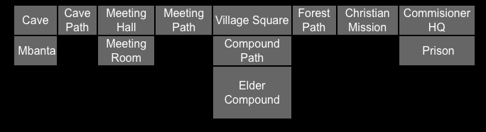
Figure 2
The map suggests schematically the village pulled between the British missionaries and district commissioner on one side and the traditional African values of the oracle and cave on the other. At one extreme the colonial prison created by the British, on the other extreme the remote traditional village (Mbanta). Okonkwo’s family is attached to the village square via the “Compound Path.” The “Meeting Hall” represents a space where Africans can discuss public issues farther from European influence. Each of the characters in the role-play is assigned a “home” where they first “wake up” and these “home rooms” group together more or less like-minded characters, the missionaries and their converts at the mission, the district commissioner and his enlisted Africans in the “commissioner HQ,” Okonkwo and leading village men in the “Meeting Room,” women at the elder compound, and so on. The activity often begins by having students as players “talk” with people in their “home” before entering other areas. (It would be possible to set certain rooms as closed to specific characters, but that is not something I have done in the Village.)

Aural Dimension: Enhanced Immersion
An attentive reading of Things Fall Apart will show the close integration of music, story telling, dance, and ritual celebration in the lives of the Igbo, and visitors to real African villages soon recognize the social importance of music even in the present day. Entering many rooms and examining certain objects in the Village of Umuofia initiates the playing of a variety of traditional West African compositions by Yaya Diallo, a Malian drummer, author, and recording artist who specializes in the djembe, an hour-glass shaped hand drum common throughout West Africa. The presence of music, and of many images of African villagers playing music, adds to the verisimilitude and interest of the virtual world. In the Village of Umuofia music functions also as background to enhance the immersive effect. Background music in immersive virtual worlds has been shown to create statistically significant increases in remembering factual aspects of those environments. (Richards, 2008)
Properties of music that are congruent with accompanying media act to highlight certain features of that media over others and hence can greatly influence how those media are remembered. (242-3)
Although I have not systematically researched the impact of the music in the Village of Umoufia, I believe it has two specific effects in this context. Because the music is new to students it enhances the sense of the experience as exotic and different; the virtual world sounds “African.” At the same time that the music is exotic, it is also attractive and even apparently joyful, thus enhancing the appeal of the African characters and village. On the website that accompanies the Village (www.literaryworlds.org/umuofia), I suggest that teachers can use West African music as another starting point for student examination of African culture and its world-wide impacts.

Visual Dimension: The Virtual Gallery
I recommend that before taking on the roles of characters from the novel, students engage in a “First Visit,” an overnight assignment to become familiar with the virtual world and write about images they found there. In this assignment the world functions as a virtual museum gallery. Visits to the gallery can be made individually or in groups. Logging in from different computers, perhaps from home, students can plan to meet each other in the virtual space at a particular time and move from room to room together viewing the photographs, which both decorate the walls and exist in different rooms as “objects” that can be opened. When viewing the Village in groups, students can talk with each other about the images they see, developing their interpretations, and a transcript of their comments is sent to themselves and to the teacher. As a gallery, the Village of Umuofia is structurally simple compared to other rich and complex worlds in our project (see “Virtual World Typology” below).
The fascinating black and white photographs in each room in the Village come with permission from the G. I. Jones Photographic Archive of Southeastern Nigerian Art and Culture administered by the Museum of Archaeology of Anthropology at Cambridge University. The images were taken in the 1930s by the anthropologist Gwilliam Jones in the same region where the novel Things Fall Apart is set and include many pictures of ritualistic artifacts and practices, village life, and even indigenous Africans dressed in apparent satire as British colonials and native messengers. These images add authenticity and interest to the virtual world.
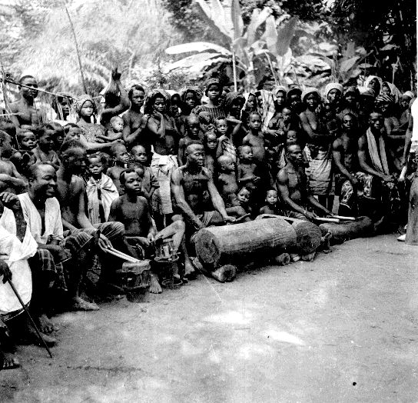 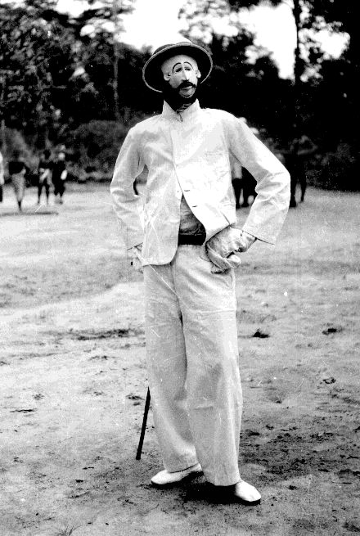
Figure 3 Figure 4
The writing that the students do in their “First Visit” helps them to compare what they have imagined from reading Things Fall Apart with the photographs taken from the same region of Nigeria. Analyzing this visual imagery connects content (textual) knowledge with student prior knowledge within the context of the virtual world technological space. Here are two representative comments from students examining images in the Village of Umuofia:
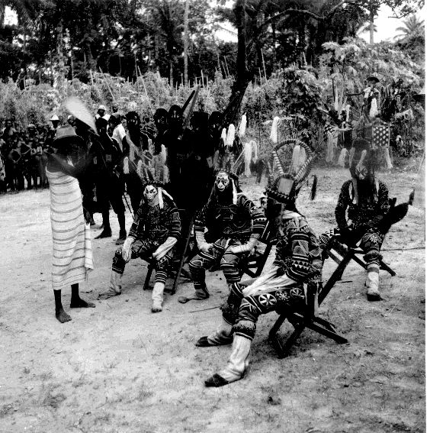
Figure 5
There appears to be some type of ceremony in progress. The villagers are dressed in what I assume to be ritual garb. Their faces are covered in elaborate masks. This scene reminds me of the chapter in Things Fall Apart where the entire village gathers to hear a trial presided over by the egwugwu. I find it so fascinating that although I’m aware that this book takes place in Africa I’m so westernized in my view of the world that I’m almost surprised to see people standing bare foot on dry earth wearing masks and feathers. The pictures are beautiful however and I just wish that I could seem them in color to get the full effect. (Student 1)
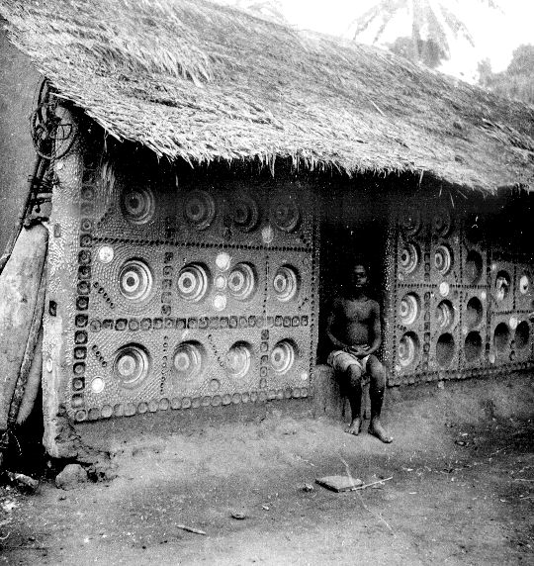
Figure 6
The most interesting image I came across was simple but very powerful and moving to me. The image involved a young man sitting on the step of a hut. The image interested me so much I think because it is so peaceful. The man is sitting there with his hands crossed in his lap, sitting in a straight up position, just gazing at the camera. The hut has quite the designs along the walls. All identical but very detailed. This images show me the humanity of these people. All too often people can view images of a different culture and see these masks and other artifacts and view them as a lesser people. But here is a peaceful person, sitting in front of a hut. The same thing one might do on a summer night. Simply sit on the porch and reflect. Also the detail of the hut shows the creativity of the people. It once again shows their humanity. I really enjoyed this image and think it is one to keep. (Student 2)
Both students view the people depicted in the images not so much as individuals but as representatives of a cultural other. In Conquest of America Tzvetan Todorov analyzes the “typology of relations to the other,”
We must distinguish among at least three axes, on which we can locate the problematics of alterity. First of all, there is a value judgment (an axiological level): the other is good or bad, I love or do not love him, or, as was more likely said at the time, he my equal or my inferior… Secondly, there is the action of rapproachement or distancing in relation to the other (a praxeological level): I embrace the other’s values, I identify myself with him… I impose my own image upon him… Thirdly, I know or am ignorant of the other’s identity (this would be the epistemic level)… (185)
Student 1 draws a connection between the image and a scene described in Achebe’s novel, suggesting some knowledge of the other from prior reading (epistemic). The picture of a person depicted as barefoot or wearing masks and feathers serves to make the student aware of the large cultural difference between her and the Ibo people; it demonstrates to her her own ignorance of their lives (praxeological). This difference seems to be the site of aesthetic pleasure; “the pictures are beautiful,” which is also a value statement (axiological). Student 2, on the other hand finds commonality between himself and the subject of the photograph, and consciously refuses to judge the depicted person as “lesser” (praxeological). The description of the image as “peaceful” and the hut designs as “detailed” constituted a positive value judgment (axiological). Student 2 strongly identifies with the other, who is seen to be performing a similar action “sitting on the porch” (epistemic).
We can begin to see from this brief analysis of the response of only two students to two images the richness of the examination of differing social worlds and perspectives that the image or gallery dimension of the virtual world can foster. Class conversations after students have undertaken the First Visit have led to many observations, questions, and new understandings about the novel. Notice how in these image analyses, students are highly self-conscious about themselves, their perspective, and distance from the Africans portrayed. As Todorov suggests, students are engaged in axiological, praxeological, and epistemic analysis of alterity. We will now consider how that self-conscious distancing is transformed by when the Village of Umuofia moves from museum gallery to a stage for live action role-play and devised work.

Verbal Interaction: The Writerly Text
During the role-play students, as characters, and write in text boxes to form a dialogue stream that allows group communication. Prompted by “events” in the village announced by the teacher students can move, communicate, and interact in an enormous variety of ways. The dialog stream of student verbal interaction in The Village of Umuofia constitutes a form of writing that extends and transforms the novel Things Fall Apart. While drawing on Achebe’s characters, the dialog that develops might be either familiar or unrecognizable to Achebe or readers of the source novel. In S/Z Roland Barthes distinguishes between the “readerly” text, “what can be read, but not written,” what he considers “classic text,” and the “writerly” text, “the goal of literary work (of literature as work) is to make the reader no longer a consumer, but a producer of the text.” Barthes believes that
our literature is characterized by the pitiless divorce which the literary institution maintains between the producer of the text and its user, between its owner and its customer, between its author and its reader. [With the readerly text] This reader is plunged into a kind of idleness… instead of functioning himself, instead of gaining access to the magic of the signifier, to the pleasure of the writing, he is left with no more than the poor freedom either to accept or reject the text.” (p. 4)
The Village of Umuofia converts Things Fall Apart into a “writerly text” where students engage in form of interactive, collaborative creative writing deeply informed by their reading and understanding of the source text. The writing that results takes place only because of a complex working together of content, pedagogical, and technological knowledges.
To research this writing we will examine a portion of a transcript taken from one of forty-nine transcripts sent to me from the Village of Umuofia on February 13, 2007, a day when I worked with an African Religion class taught by Dr. Mustafa Mirzeler at Western Michigan University. This was the fifth time that I had personally directed the use of The Village of Umuofia, and working together Dr. Mirzeler carefully wove the activity into his lesson plans, including having the students know their identity before the role-play, having them engage in the First Visit (samples above are from this class), and having them write and discuss the experience and complete a survey afterward. The transcripts are generated as recordings of the conversations that take place in each of rooms the student visits during the role-play. Since there are thirteen rooms in the virtual Village of Umuofia, at any one time there could be thirteen different conversations going on. Students who are in a room together at a given time will have the same transcript for that portion of their transcript. At the end of the role-play transcripts are sent to the student and their teacher. Printed below is approximately one-fifth of one student’s transcript, a transcript that was created during the twenty-two minutes that she participated in the activity. This is obviously a tiny part of the mass of transcripts generated, and was selected randomly.
During normal play, students role playing characters can come and go from the rooms. The teacher usually role-plays a unique character, the Village Crier, who has several special powers. This teacher-character can speak so as to be heard in every room at the same time, can “lock doors” so that students cannot move between rooms, and can magically transport groups of characters to different rooms, such as placing all the British and British sympathizing characters in the same room, all the African traditional characters in the same room, all the characters in the same room, all the characters spread in small groups throughout the village, and so on. There are thirty-nine possible characters in the village, and during this role-play all were used, and some characters were played by two students working together at the same computer. The activity lasted for one hour forty minutes, and during that time some students logged in and out (thus creating more transcripts than the total number of characters). Although the event took place during the regular hour of the class meeting, students are at computers either at home or in dispersed locations.
This transcript is from the room called “Village Center,” and while characters come and go, and there are at the most nineteen characters present at any one time. These characters include traditional Ibos, including the novel’s main character Okonkwo, members of his family including his father, three wives, a son and daughter, respected tribal leaders, Africans from other villages, and one of the British missionaries. The discussion begins when the teacher announces an event that actually happens in the novel. As you read the transcript watch for the relations between characters, how they interact based on their roles, and how the conversation develops. Consider what the students might be learning from the activity, and how the activity and student writing compare with other language arts activities. (The transcript has been edited for spelling and punctuation.)

Village Crier [the teacher] announces "Attention Villages of Umuofia: It is Peace Week and Okonkwo, while angry at his youngest wife, has beaten her mercilessly. PLEASE DISCUSS THIS EVENT."
Okagbue [medicine man], says, "Okonkwo has committed a grievous error."
Chielo [priestess of oracle], says, "How could Okonkwo do such a thing!"
Ekwefi [Okonkwo’s second wife], says, "Okonkwo is sadly prone to anger. "
Ukegbu [senior member of the clan’s sacred society], says, "I am very mad and upset with his action."
Ozoemena [female survivor of a massacre of another village], says, "Okonkwo should be punished."
Okagbue says, "This kind of thing has not happened for many generations and must be punished."
Nwoye [Okonkwo’s son] says, “Our yams will not grow now."
Mr. Kiaga [Christian convert from a different village] says, "There is no excuse for his behavior."
Obierika [Okonkwo’s friend] says, "Okonkwo should not have struck his wife in the week of peace."
Unoka [Father of Okonkwo] says, "Okonkwo is the best fighter in the village."
Chielo says, "Yes he should be punished."
Ojiugo [Okonkwo’s youngest wife] says, "He is just a physical man."
Ukegbu says, "It is to be a week of peace not violence."
Uchendu [Okonkwo’s uncle] says, "He must make up for his actions. Then all will be right."
Chielo says, "He needs to make the proper sacrifices to make up for this incident."
Ozoemena says, "The Gods will be angry."
Ekwefi says, "I will comfort his wife."
Ojiugo says, "I am used to his beatings."
First Wife [Okonkwo’s eldest wife] says, "But this is Peace Week; it is not acceptable."
Akueke [daughter of Obierika, Okonkwo’s friend] says, "There is no way I would let my husband beat me, especially during Peace Week."
Obierika [friend of Okonkwo] says, "If a man was to rob another man the one robbed must wait until Peace Week has ended before taking action."
Unoka says, "His wife is probably in much pain. I will play music for her."
Nwoye says, "He must sacrifice to the gods so that our yams will still grow."
Mr. Smith [Christian missionary] says, "Beating one’s wife is a sin any time of the year."
Ojiugo says, "But I was shocked that he would beat me during the week of peace."
Ibe [fiancé of Akueke] says, "I can't believe such a good man would do such harmful things to his wife."
Okagbue says, "No one must be above the law. To allow this shame to go unpunished would be to invite chaos into our presence."
Obiageli [daughter of Okonkwo] says, "The elders say they can only remember two or three times when the Peace Week has been disgraced."
Ekwefi says, "Ojiugo, I will take care of your duties today. You should rest."
Ibe says, "May peace be with us."
Okonkwo says, "I was hungry and she didn't cook. She needed a good beating!"
Mr. Kiaga says, "It is not our place to punish him; God himself will punish Okonkwo."
First Wife says, "We three wives must stick together."
Mr. Kiaga says, "Not our Gods, the White Man’s God."
Uchendu says, "Okonkwo are you mad? It is Peace Week. No man should beat his wife during this time."
Ibe says, "You have two other wives Okonkwo, not one will cook for you?"
Obierika [Okonkwo’s friend] says, "A wife is less likely to cook after being beaten; even a fool knows that."
Okagbue says, "Perhaps, Okonkwo, but NOT during peace week"
Chielo says, "Okonkwo... you knew what week it was... there is no excuse!"
Kotma [African who works for the British commissioner] says, "Your god is too savage."
Akueke says, "Why would he do that to his wife? Dinner isn't cooked once and he lashed out..."
Unoko says, "Okonkwo will see his faults."
Okagbue says, "You show a lack of respect for our traditions by acting so foolishly."
Unoko says, "When his wife is not able to care for him."
Ojiugo says, "I try my best to care for him. A wife's work is much harder than most men think."
Mr. Kiaga says, "It is not right to beat another person, for any reason."
Mr. Smith says, "Okonkwo needs to repent from his sins and give up his pride. He is a very proud man."
Okagbue says, "Perhaps you are correct, Mr. Kiaga, but our ways are not your ways."
Kotma says, "Okonkwo you have to pay 200 cowries for your crime."
Mr. Kiaga says, "My ways were once your ways."
Unoka says, "You have brought your family shame."
Okagbue says, "And you left us, Mr. Kiaga. You have become a servant of the white man and his ways."
Mr. Kiaga says, "No, I am simply showing you the way."
Ekwefi says, "Mr. Kiaga, what will happen to your ancestors? Who will care for them if not you?"
Okagbue says, "Your ideas are divisive, Mr. Kiaga. Go back to your white men and leave us be."
Mr. Smith says, "The bible says that polygamy is a sin. Maybe if Okonkwo had one wife he would not feel so stressed…. He is breaking God's law!"
Ekwefi says, "Perhaps Peace Week would be less prone to violence if the men could wrestle away their anger."
Mr. Kiaga says, "Yes, Mr. Smith."
Ekwefi says, "It would provide a good time for everyone."
Unoko says, "The bible?"
Uchendu says, "Your God's law is not our law."
Ukegbu says, "We don’t believe in the bible, Mr. Smith."
Nwoye says, "But that would violate the peace."
Mr. Kiaga says, "One wife is God’s way."
Okagbue says, "And did you not also teach, Mr. Smith, that your Abraham had more than one wife?"
Unoko says, "That God does not respect our ways""
Ibe says, "Amen to that Mr. Smith."
Chielo says, "He is breaking no laws of ours with his many wives, Mr. Smith."

The transcript shows student writing as highly interactive and fast paced. Students rarely write more than a sentence or two before entering it into the conversation, and sometimes it is difficult to know exactly to whom responses are directed. The pace is amplified by having so many characters present; at the same time in the village there may be rooms where there are only three or four characters and the conversations are slower and involve longer entries. (Some who use this platform believe that five or six is the ideal number.)
This interactive dialog is deeply engaged in the content of literary work the students are reading and shows a high degree of character identification. Even in this short passage there are dozens of ways that immersion in the content is evident. The writing expresses knowledge of individual characters and their relationships with others and, as students continue to “speak” as their character they explore character motivation, both as individuals and as participants in different groups in the village and different cultural groups, Ibo and British. In this sense the writing expresses substantial social knowledge. For example the apparently simple comment by the student playing Ekwefi (Okonkwo’s second wife), "Okonkwo is sadly prone to anger. " Demonstrates not only knowledge of Okonkwo’s behavior, but the word “sadly” demonstrates the student’s knowledge of affection between Ekwefi and Okonkwo, that such behavior is wrong in the context of the novel, especially during Peace Week, and the tone, factual not outraged, suggests that such behavior is common, if not entirely acceptable in the Ibo world of Achebe’s novel. Another example of demonstrating content knowledge takes place when the student playing Ekwefi says, "Ojiugo, I will take care of your duties today. You should rest." In the novel Okonkwo’s wives, despite jealousies, perform understated actions to help each other. Often student demonstration of content knowledge is subtle. When the student playing Uchendu (Okonkwo’s uncle) says, "He must make up for his actions. Then all will be right” referring to Okonkwo beating his wife, there is a close fit with events later in the novel when Okonkwo must be punished for inadvertently killing a tribal member by a banishment that will balance the action – indeed, it is character Uchendu who takes Okonkwo in to his village in the novel. The student here playing Uchendu draws on knowledge of the character from events later in the novel and projects that knowledge backward to the earlier event of the wife beating to devise a statement for the thinking of the role-played character.
The transcript also shows students performing not only personally different viewpoints, but cultural conflicts in complex, multiple, and interacting social worlds. The comment by Mr. Smith, the Christian missionary, that, "Beating one’s wife is a sin any time of the year" demonstrates the student’s awareness of the social and religious beliefs of the British and how they contrast with the Ibo (epistemic). When Mr. Smith says, "The bible says that polygamy is a sin. Maybe if Okonkwo had one wife he would not feel so stressed…. He is breaking God's law!" the student goes a step further, not only making a cultural comparison and judgment (axiological), but devising an analysis of behavior based on a differing belief system (praxeological). One of the most interesting interactions involves students the dialog about Mr. Kiaga, an African from the coast who speaks Ibo with a different accent and dialect and who has been “educated” by the British to become a Christian minister. Here we have a complex cross-cultural situation. When Mr. Kiaga says, "My ways were once your ways." the student performing this character demonstrates/performs assimilation as a value, which allows him to both relate to the other African characters and offer himself as a model for a change in their behavior and values. Unoka says, "You have brought your family shame." (an appropriate remark given his role as a father figure in the novel) and when Ekwefi says, "Mr. Kiaga, what will happen to your ancestors? Who will care for them if not you?" they are both American students projecting themselves into the hypothetical position of an Ibo villager and responding to an Ibo from a different village who has been assimilated in Western culture. Although the student role-playing Okagbue has most likely not read Frantz Fanon’s analysis of the psychology of the colonized, when he says, "And you left us, Mr. Kiaga. You have become a servant of the white man and his ways." and, "Your ideas are divisive, Mr. Kiaga. Go back to your white men and leave us be." he is insisting on a Manichean understanding of the colonial context that Fanon described as necessary for the colonized to adopt to free themselves of European domination (Fanon, 1961). In both cases the Manichean argument arises as a response to the valorization of assimilation to Western culture and values.
The transcript of the student performances does not just express a sophisticated content knowledge, it actively and creatively extends this knowledge. Again there are many interesting examples in the cited passage. When the student playing Okonkwo’s close friend Obierika says, "A wife is less likely to cook after being beaten; even a fool knows that," he makes a statement of information that is actually not known from the novel, but one which might be inferred based upon behaviors described in the novel, or projected based upon knowledge of human nature that the student brings to the text and ensemble production of the virtual role-play. (I note that the sentence uttered here by student performing Obierika does seem especially appropriate to Obierika’s character in the novel; it is thoughtful and shows a flexibility of mind not merely controlled by accustomed behavior. It demonstrates a willingness to judge his friend Okonkwo, though not necessarily disloyalty to him.) When Okagbue says, "And did you not also teach, Mr. Smith, that your Abraham had more than one wife?" he adds an argument that was not in the novel but which makes perfect sense given the extensive conversations some of the Ibo characters have had with missionaries.
While this transcript does not demonstrate it, in the Village of Umuofia students sometimes transgress strict adherence to remaining “in character,” writing in a way that self-consciously violates the time period and cultural situation. This writing is often humorous or playful, and the humor depends upon the juxtaposition of culturally inappropriate language or ideas. In some circumstances this can be seen as teachers to pose a challenge to the “intended” activity certain challenges. After the activity one student wrote,
People started goofing around and just chatting for the heck of it. Once that happened, there was almost no way to restore order, and, consequently, the assigned missions went unaccomplished. Personally I found the conversations fun and humorous; but I’m pretty sure that it was not supposed to be that way by means of joking and mockery.
This student’s comments suggest that the virtual role-play activity generates both it own expected norms and counter norms. While this “mockery” may very well have intellectual interest, even value worth examining or designing in, as a developer of the world the tendency has been to create protocols that diminish this behavior. In the role-play the teacher cannot be in every room at the same time, yet the transcripts allow teachers to assess, evaluate, and hold students accountable for their participation after the event, and the role for the teacher as Village Crier who can enter conversational topics, move students, and lock doors. In this way teachers can reduce activity that they view as “off task.”

Student Assessment of the Village of Umuofia
Regarding the virtual world activity on 2-13-07, students were overwhelmingly positive about their experience in the Village of Umuofia. Thirty-four students completed a survey about their experience, twenty-six were female and eight male. (Approved HSIRB protocols required that the professor be out of the room while the survey was administered and students be informed he would not see survey results until after grades were submitted.)
 | YES | NO
1. Was this your first time in a virtual world? | 33 | 1
2. Did the activity help you better understand characters and motivation? | 29 | 4
3. Did the activity help you understand historical context and themes? | 26 | 7
4. Was it enjoyable? | 28 | 5
5. Was it intellectually stimulating? | 27 | 6

Figure 7
Although the numbers are too small to make firm conclusions, males were even more positive than females. (For questions 2-5 there was only one male that responded “no.”) Typical written comments included:
It made the character come alive and allowed me to imagine myself in that time and environment.
The music and the images really helped to make me feel more a part of the village and my character.
It was interactive, fun, and much better than a traditional lecture.
It helped me to get a better understanding of the book.
It made the material easier to relate to for me.
It reminded me of class discussion, but this took those discussions to a whole new level.
A lot was going on and so many people were talking at times it was hard to follow.
The world was extremely stimulative, almost to a fault.

Continuous Development of Technology, Pedagogy, and Content Knowledge
Repeated experimentation with these virtual worlds is essential to developing pedagogical knowledge and strategies, and to refine and develop technological knowledge so that the world can be developed to foster student content learning. Beta testing of the Village of Umuofia indicated that as they “escape” from the confines of regular classroom in the virtual world some students race quickly around the world or engage in partly out-of-character dialog just discussed. Thus our development of the ability of the teacher to transport characters to certain rooms and “lock doors” as well as the transcript function. Early tests with the village also indicated the importance of students developing thinking from the point of view of their character before entering into the virtual experience. Thus we evolved, as mentioned, pedagogies to prepare students for virtual world participation. During early experiments with the village I held what I later considered to be unrealistic expectations for what kind of actions could be taken during the role-play. I thought, for example, that characters might make collective decisions to take specific actions, such as groups of traditional Africans deciding to burn down the missionary church (as happens in the novel) or the British district commissioner deciding to take some of the African leaders prisoner (another event from the novel). While several of the Literary Worlds have been designed to allow for quite complex character actions and collaborations, I did not develop the technology/pedagogical/content knowledge I needed to make this kind of collaborative activity possible in the Village of Umuofia. Rather than this lack of knowledge becoming a handicap, however, eventually it allowed me to recognize that the Village functions well as a conversational space. Clarifying this expectation allowed me to help other teachers using the resource. Continued improvements are also possible.
I believe that the Village of Umuofia is a richer experience when students write and discuss about what they are learning during, or soon after, the activity. It would be valuable for them to analyze at least a portion of the transcript of their experience. Questions they might consider include: How was our experience similar to and how different from the novel? Why did certain characters act the way they did during our experience in the Village of Umuofia? How has the Village of Umuofia virtual reality changed or enhanced my understanding of the novel and the historical events on which it is based?

Typology of Virtual Worlds for Literary Study
The shape, function, and pedagogy of virtual literary worlds are diverse and deeply connected to the pedagogical purposes and literary work that serves as it source (content), pedagogical goals, and the virtual world builder’s manipulation of the technological environment. In the Literary Worlds Project virtual worlds emerging in at least seven distinct on-line forms:

1) Intertextual Map: As themselves, participants follow a virtual path through the setting of a literary work. Examples: Woolf’s London based on early 20th Century photographs of the city, closely follows two walking trips that main characters in Virginia Woolf’s Mrs. Dalloway take through downtown London and explore the connection between their inner thoughts and the urban geographical landmarks in the novel includes extensive period maps, and textual selections from the novel paired with images of actual locations or objects described. Bigger’s World provides a similar resource in the 1930s Chicago African American neighborhood of Richard Wrights’ novel Native Son.

2) Virtual tour: Participants individually or in groups enter as themselves and explore and interact in a world based on literary sources. Examples: Dicken’s London -- In a 19th Century version of London based on three Dickens novels students encounter a complex city of images, textual fragments and characters (bots) that they can speak with from the novels.

3) Role Play Stage: The virtual world provides a geographical, visual, and auditory environment, avatars are based characters from source texts, multiple participants engage in dialog in character. Examples: Village of Umuofia based on Things Fall Apart (described above); Gatsby’s American Dream -- Five characters from the novel return to the locations of the novel as “shades” of their former selves and discuss events from the text; Lord of the Flies Virtual Island – A series of characters based on the text recreate life on the island; Mice, Men, and Migrant Labor – characters from the 1930’s novel about migrant labor in California (Of Mice and Men) and a 1960’s novel about migrant Mexican Americans in the Midwest (The Earth Did Not Devour Him) first meet in their own worlds, then a door is opened and they enter into dialog with each other.

4) Alternative Reality Game: On a role play stage, participants as avatars engage in activities with specific goals and rules based on principles or objectives from the source text. Examples: Midsummer Madness, after reading the first act of the play students enter an enormous virtual world based on the play, all have separate entrances and assigned, interrelated goals activities based upon roles in the play; The Tempest Virtual Island, similar to Midsummer Madness; and, “Thought Crime” characters assume roles from Orwell’s 1984 of outer party, inner party, and thought police and engage in a high stakes detective game.

5) Second World: Students become builders and design a virtual world that parallels the world of the novel. Example: Brave New World MOO based on the Huxley novel students designed a world that not only included buildings and spaces mentioned in the novel, but additional spaces that were conceivable based on the novel. This world also functioned as a Role Play Stage – students designed their own character as well -- and as a virtual classroom where students discuss the novel and related topics. See Rozema (2003).

6) Textual Riff: Student become builders and, along with the professor, gather historical, cultural, literary and interpretative texts and images that respond to the source text. Examples: Pied Piper based on the medieval legend; Island Barrio based on Judith Ortiz Cofer’s An Island Like You.

7) Virtual Museum: An archive of image, sound, and cultural materials as a supplement to a specific literary work, can be entered by individuals or groups who may then engage in conversation. Examples: Angel’s Space based on Tony Kushner’s play Angels in America; The Immutable Hill set primarily in Hawaii, also involves scenes in California and South East Asia and refers to a wide spectrum of international events during the Vietnam and Cold War based on Joan Didion’s novel Democracy; Anglo-Saxon Mead-Hall based on Anglo Saxon poetry and epic; Moll’s World based on Moll Flanders; Inismore based on Wild Irish Girl.

Conclusion
Effective technology integration for pedagogy around specific subject matter requires developing sensitivity to the dynamic, transactional relationship between all three components. A teacher capable of negotiating these relationships represents a form of expertise different from, and greater than, the knowledge of a disciplinary expert (say a mathematician or a historian), a technology expert (a computer scientist) and a pedagogical expert (an experienced educator).
Punya Mishra
A literary virtual world is both a technology-enhanced interpretation of the source text and a pedagogical tool. Mastering the technology to build a virtual space in enCore is not so difficult, but designing virtual spaces that will be truly engaging for students while creating significant content-based learning constitutes a challenge. To develop a successful virtual world learning activity requires projective skill at working together content, pedagogy, and technology. As virtual world developers, teachers need to imaginatively put themselves into the position of students experiencing the virtual world they intend to create, and, then, as classroom leaders, teachers must adequately prepare students to enter into a virtual world learning experience by developing necessary prior knowledge. In Literary Worlds that typically, but not always, means that students have carefully read the literary work and perhaps engaged in specific activities designed to prepare them for the virtual world activity. English teachers versed in reader response pedagogies have an important advantage in designing virtual worlds over colleagues who have an “information transfer” model of learning. One experience of the Literary Worlds project was that the literary scholars designing these worlds, excellent teachers themselves, tended to think of learning as closely examining textual passages or acquiring additional information relevant to understanding the literary work. It was easier for some virtual world builders to imagine virtual museum spaces rather than interactive role-play, gaming, or building environments. Certainly the enCore platform allows museum or gallery-like spaces to be rich and contextual, and, just as modern museums do, to permit interactivity and collaborative learning. When carefully developed and well integrated into classroom learning, all forms of virtual worlds have significant potential to enhance student learning. The Literary Worlds Project brings together content, pedagogical, and technological knowledges making possible new forums for reading and responding to literature.

REFERENCES
Burn, Andrew (2005). “From the Tempest to Tomb Raider: Computer Games in English, Media and Drama.” Telemedium 52.1/2 Spring 2005: 50-4.
Carey-Webb, Allen (2001). Literature and Lives: A Response-based, Cultural Studies Approach to Teaching English. Urbana: NCTE Press.
Fanon, Frantz. (1961). The Wretched of the Earth. New York: Grove Press.
Feffer, Laura (2009). “Devising Ensemble Plays: At-Risk Students Become Living, Performing Authors.” English Journal 98.3 January 2009: 46-51.
Gee, James (2003). What Video Games Have to Teach us About Learning and Literacy. New York: Palgrave Macmillian.
Hoover, Wesley. (1996) “The Practice Implications of Constructivism” SED Newsletter 9.3 August 1996. http://www.sedl.org/pubs/sedletter/v09n03/practice.html
Jackson, Shelley (1995). Patchwork Girl by Mary/Shelley and herself. Watertown, MA: Eastgate Systems. Electronic. http://www.eastgate.com
Johnson, Steven (1997). Interface Culture: How the New Technology Transforms the Way We Create and Communicate. San Francisco: Harper Collins.
Koehler, Matthew and Punya Mishra (2009). TPACK Technological Pedagogical Content Knowledge. http://www.tpack.org/tpck/index.php?title=Main_Page Accessed 3-8-09.
Lancaster, Kurt. (1999). Warlocks and Warpdrive: Contemporary Fantasy Entertainments with Interactive and Virtual Environments. Jefferson, North Carolina: McFarland & Co.
Mishra, Punya. Punya Mishra’s Web. http://punya.educ.msu.edu/research/tpck/ Accessed 4-8-09.
Murry, Janet (1997). Hamlet on the Holodeck: The Future of Narrative in Cyberspace. Cambridge. MA: MIT Press.
Osberg, Kimberly. (1992) “Virtual Reality and Education: A Look at Both Sides of the Sword.” Human Interface Technology Laboratory. http://www.hitl.washington.edu/publications/r-93-7/, accessed 3-11-09.
Rozema, Robert (2003). "Falling into Story: Teaching Reading in the Literary MOO." English Journal 93.1: 33-38.
Rozema, Robert. (2004). Electronic Literacy: Teaching Reading and Literature in a Digital Age. Doctoral Dissertation, Western Michigan University.
Richards, Debbie, Eric Fassbender. Ayse Bilgin, and William Forde Thompson (2008). An Investigation of the Role of Background Music in IVWs for Learning.” ALT-J, 16.3 September 2008, 231 – 244.
Ryder, Martin. (2008) “The Cyborg and the Noble Savage: Ethic in the War on Information Poverty.” http://carbon.cudenver.edu/~mryder/savage.html#def_constructivism accessed 3-7-2009
Spivak, Gyatri. (1990) The Postcolonial Critic: Interviews, Strategies, Dialogues.” Edited by Sarah Haraysm.
Wilhelm, Jeff. (1997). You Gotta BE the Book: Teaching Engaged and Reflective Reading with Adolescents. New York: Teachers College Press.

BIOGRAPHY
Principal investigator in the Literary Worlds project, Dr. Allen Webb, is a professor of English at Western Michigan University with scholarly interests in English education, postcolonial and minority literatures, and Internet learning. He has authored and edited five books in literary study and the teaching of English, including Literature and Lives: A Response-based Cultural Studies Approach to Teaching English (NCTE 2001) and, with Robert Rozema, Literature and the Web: Reading and Responding with New Technologies (Heinemann, 2008) more than 25 articles, and over 100 conference presentations. A former high school teacher, he is an active member of the National Council of the Teachers of English and the Conference on English Education.

Funded by $118,000 2006 WMU Presidential Innovation Grant the Literary Worlds Project includes English education professors (Allen Webb and Robert Rozema (GVSU)), literary scholars (Todd Kuchta, Jon Adams, Steve Feffer, Cynthia Klekar, Todd Kuchta, Casey Mckittrick, Chris Nagle, Gwen Tarbox), doctoral students (Todd Bannon, Joe Hughey, Ilse Schwietzer, Gretchen Voskuil), instructors (Linda Dick), high school English teachers (Cara Arver), undergraduate secondary English majors (Jennifer Barns, Meghan Dykma, Tim Heacock), and a technology specialist (Kevin Jepson). The project is found on-line at www.LiteraryWorlds.org.

